Discount Plugin

we have to set the discount percentage from 0 % to 100 %. IF input data is not in range (1-100)% then error message wil be show.
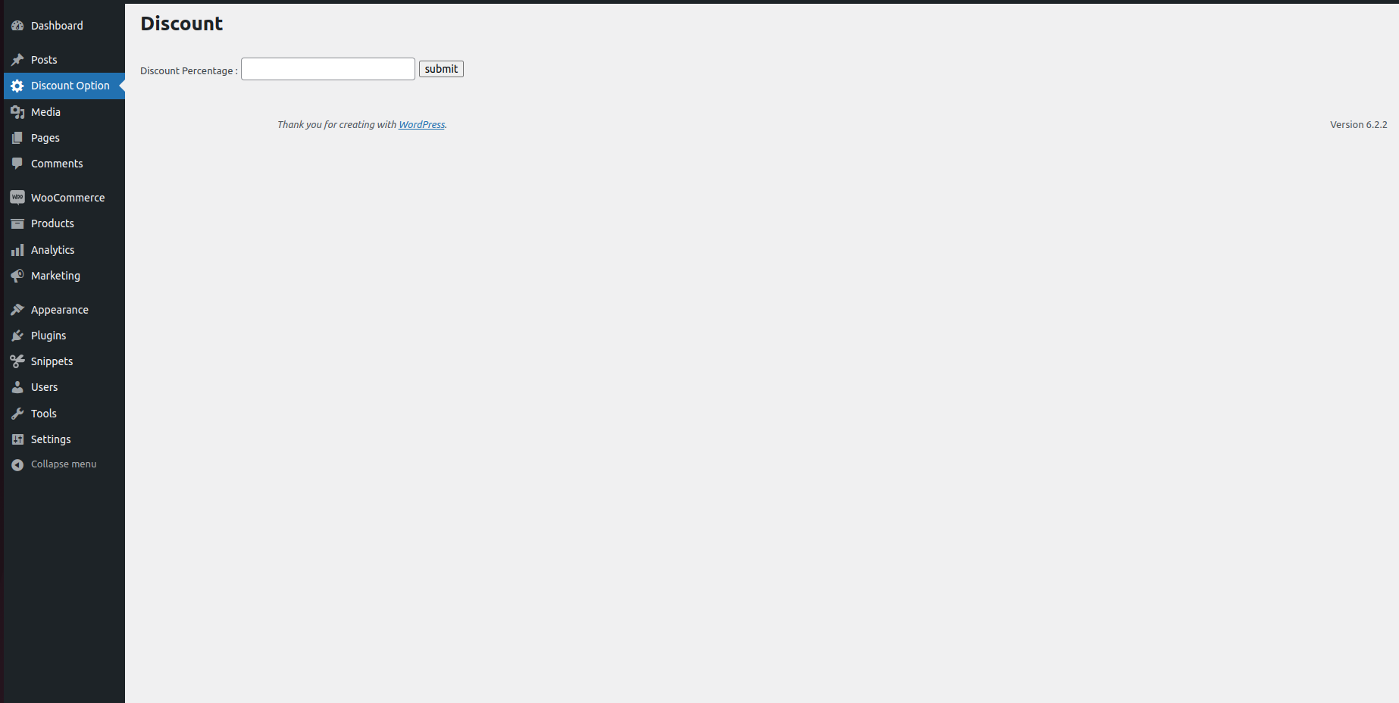
Input discount will appear on front end.
